International Convention
1-5 June 2019Hamburg, Germany

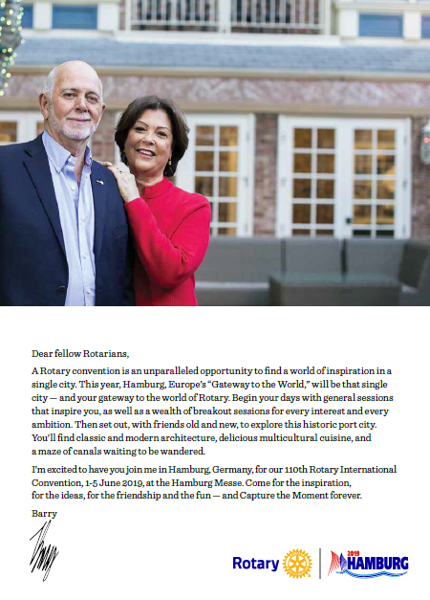

STED

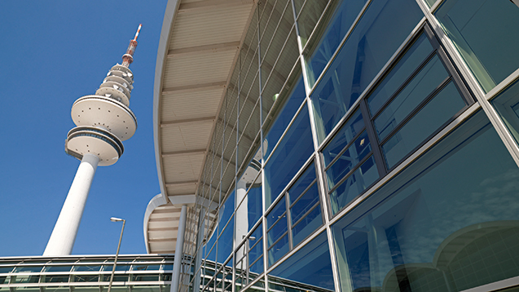

Hamburg Messe
Messeplatz 1
20357 Hamburg, Germany
Hamburg Messe er stedet for konvensjonens generelle økter, breakout-sesjoner og House of Friendship.

Program

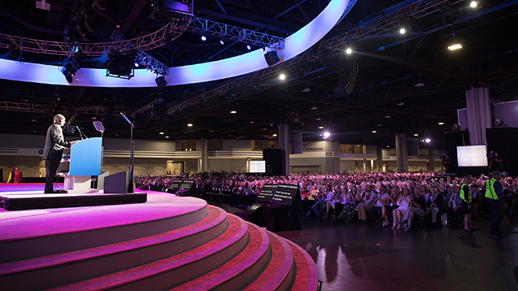

Events/begivenheter
Fang øyeblikkene dine i Hamburg. Benytt deg av de mange arrangementene og aktiviteter planlagt av Rotary, vertsorganisasjonskomitéen og Rotary medlemmer.

Se utdrag fra programmet nedenfor.

House of Friendship

Det er her Rotary verden kommer sammen for å utveksle ideer og prosjekt-suksesser.

Breakout økter

Breakout økter gir deg muligheten til å grave dypere inn i emnene som interesserer deg.

Pre-kongress begivenheter
Våre «pre-kongress» begivenheter vil stimulere og inspirere deg, og forberede deg på en minneverdig kongressopplevelse.

Program
Utdrag fra programmet:

Rotaract Preconvention
For Rotaract and Rotary members interested in Rotaract.
31 May-1 June | $125

Youth Exchange Officers Preconvention
For Rotary members who work with Youth Exchange.
31 May-1 June | $125

Youth Exchange Officers Banquet
For Youth Exchange Officers Preconvention participants and their guests, but all convention registrants are welcome.
31 May | $125

Rotary Peace Symposium
All Rotary members and non-members are invited to attend
31 May-1 June | $150

President’s Recognition Luncheon
For current RI officers, district governors, club presidents, RI committee members, and partners, but all convention registrants are welcome.
3 June | $60

President-elect’s Leadership Luncheon
For incoming RI officers, district governors, club presidents, and their partners, but all convention registrants are welcome.
4 June | $60

Rotary Club Celebration Luncheon
All convention registrants are welcome
5 June | $60

Host-ticketed events
The Hamburg convention’s Host Organization Committee is planning an unforgettable experience for all attendees. Visit the HOC site to learn about the many events, tours, and activities available to help you get the most out of your visit.

Rotary moments – toronto 2018

